## Introduction

In our increasingly interconnected world, the need for robust and adaptable home security systems has never been more critical. This report delves into the design and implementation of an Arduino Uno based home security system, a project that seeks to provide a customizable and cost effective alternative to traditional security solutions. Going beyond the basics, this system incorporates an array of sensors potentiometer, a PIR motion sensor, Servomotor and even a laptop camera to detect a range of potential threats. When suspicious activity is detected, the system responds by triggering a buzzer, activating a simulated door lock, and providing visual status updates via an LED. Additionally, it establishes a communication link with a laptop for enhanced monitoring and potential image capture of intruders. This project illustrates the power of microcontrollers in crafting intelligent and responsive security systems, capable of addressing the diverse and evolving security needs of modern homes. The system's ability to integrate various sensors and peripherals also highlights its versatility and potential for future expansion.

## 2. Background

Traditional home security systems often come with hefty price tags and limited adaptability, forcing users into a one-size-fits-all approach. These systems, while effective to a degree, can be cumbersome to install, expensive to maintain, and may not always cater to the specific vulnerabilities of a given property. However, the emergence of open source platforms like Arduino has democratized access to sophisticated technology, empowering individuals and small communities to take a more active role in safeguarding their homes. By leveraging the Arduino Uno, this project taps into the principles of embedded systems, sensor technology, and mechatronics to offer a functional and adaptable security solution. This initiative acknowledges that every home has unique security needs, stemming from differences in architectural design, location, and the value of possessions, and strives to empower users to tailor their systems accordingly.

## 3. Methodology

At its core, this project is about alertness and swift response. The Arduino Uno is programmed to continuously monitor the environment through a series of sensors. When a potential threat is detected that can be an open window, unauthorized movement, or a hazardous condition, the Arduino springs into action, activating a series of responses. The system is designed not only to detect these threats but also to provide immediate feedback and deter further intrusion, showcasing the potential for automated security measures in a home setting.

### 3.1 Sensor and Related Equipment Used

* **Arduino Uno:**

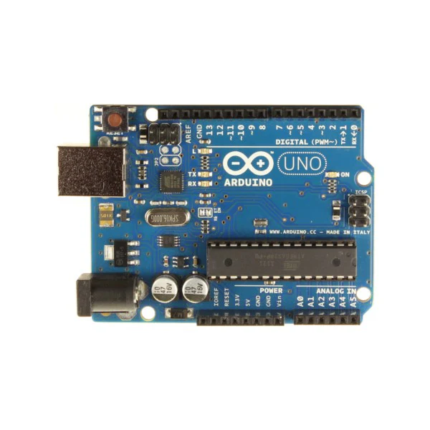Think of this as the brain of the operation. It's a microcontroller board that reads information from the sensors, processes it, and then tells the other components what to do. The Arduino Uno's versatility, ease of programming, and wide availability make it an ideal choice for this project. Its digital and analog input/output pins allow it to interface with a variety of sensors and actuators, making it a central hub for the security system.

### **Potentiometers (x2):**

**Hazard Level Simulation:** One potentiometer acts as a stand-in for a hazard sensor, like a smoke or gas detector. By turning the knob, we simulate different levels of danger, and the Arduino can react accordingly. This allows for testing and demonstration of the system's response to varying degrees of threat, providing a practical way to showcase its functionality.

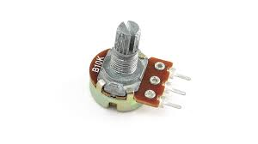

**Window Lock Simulation:** The second potentiometer simulates the position of a window lock. This allows the system to detect whether a window is open or closed, adding another layer of security. This is particularly relevant in areas where window intrusion is a common concern. The potentiometer provides a simple yet effective way to model this critical security aspect.

* **PIR Motion Sensor:**

This sensor is like a watchful eye, detecting movement by sensing changes in infrared radiation. If someone moves where they shouldn't, the PIR sensor will let the Arduino know. PIR sensors are widely used in security systems due to their reliability, low power consumption, and ability to detect movement without requiring physical contact.

* **Servo Motor:**

This is our simulated door lock. When a threat is detected, the servo motor will move to a "locked" position, mimicking the action of a real security mechanism. Servo motors offer precise control and can be easily integrated into a variety of locking mechanisms, making them a suitable choice for this application. The simulation provides a clear demonstration of how the system can automatically respond to a security breach.

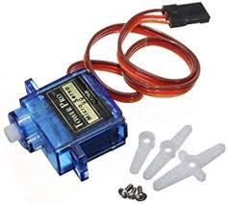

* **Buzzer:**

This is the alarm. When a threat is detected, the buzzer will sound, alerting anyone nearby. The buzzer serves as an immediate deterrent, drawing attention to the security breach and potentially discouraging further intrusion. Different types of buzzers can be used to create varying sound levels and patterns, allowing for customization of the alert.

* **LED:**

This is a visual indicator, providing feedback on the system's status. For example, it might blink to indicate that the system is armed or stay solid to show that it's active. LEDs are versatile components that can be used to communicate a range of information, such as system status, alarm activation, or sensor malfunctions.

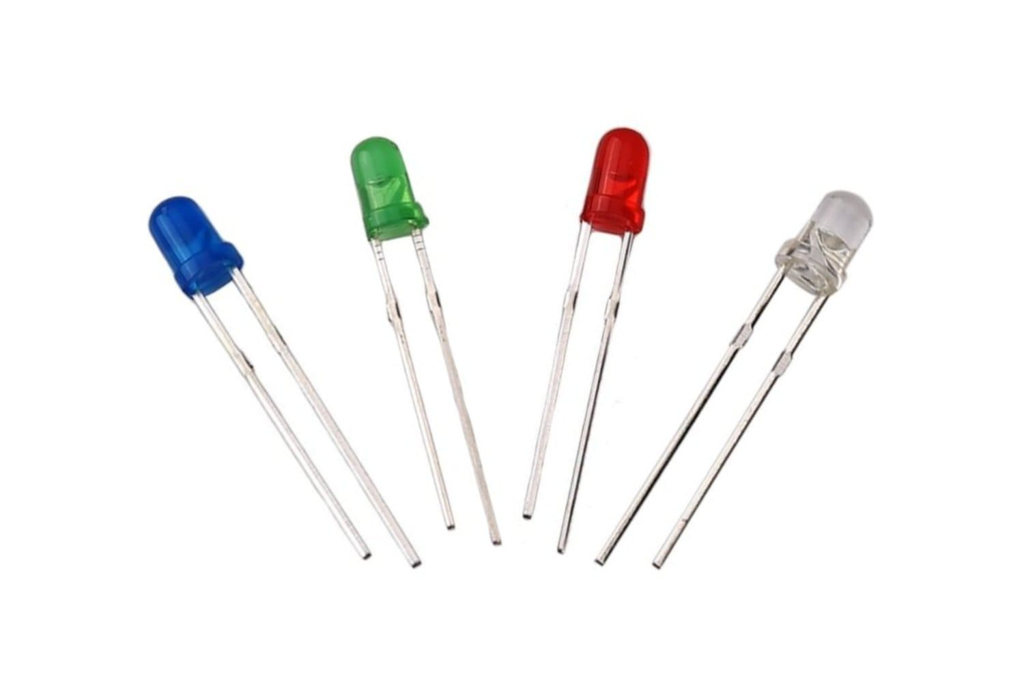

* **USB Connection to Laptop:**

This connection allows the Arduino to communicate with a laptop. This opens up possibilities for more advanced features, such as logging events, displaying sensor data, and potentially capturing images. The USB connection provides a reliable and well established communication channel, enabling seamless data transfer between the Arduino and the laptop.

* **Laptop Camera:**

Working in conjunction with the USB connection, the laptop camera can be used to capture images when a security breach is detected. This could provide valuable evidence or help in identifying intruders. The integration of a camera adds a significant layer of security, allowing for visual documentation of events and potentially aiding in post-incident analysis.

## 4**. Circuit Diagram**

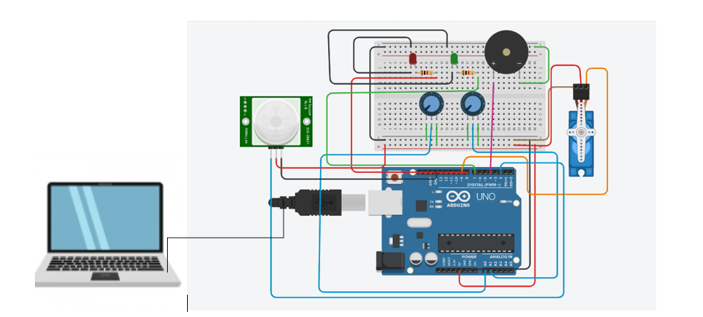Here's a breakdown of how everything is connected.

|  |  |  |
| --- | --- | --- |
| **Component** | **Arduino Connection** | **Remarks** |
| Hazard Potentiometer | A1 (analog input) Outer pins to 5V and GND, wiper( middle pin) to A1 | This provides the necessary voltage for the potentiometer to operate. |
| Window Potentiometer | A0 (analog input) Outer pins to 5V and GND, wiper to A0 | The wiper's voltage here indicates the position of the simulated window lock |
| PIR Motion Sensor | D2 (digital input)  VCC to 5V, GND to GND, signal to D2 | The signal pin outputs a digital signal (HIGH or LOW) depending on whether motion is detected. |
| Servo Motor | D9 (PWM digital output)  Power to 5V, GND to GND, signal to D9 | D9 (this pin must be a PWM pin). PWM is a technique used to control the angle of the servo motor. |
| Buzzer | D4 (digital output) | Through 220-ohm resistor to limit current and prevent damage |
| LEDs (Green, Yellow) | D7 (Green), D8 (Yellow) | A resistor is crucial here to limit the current and prevent the LED from burning out. |
| USB Cable | Laptop USB port | Serial communication |
| Laptop Camera | Laptop integrated hardware | This involves openCV library to control the camera and capture images when the Arduino sends a signal. |

## 5. Communication Technology and Network Topology

In its basic form, this system is a standalone setup. However, we can expand its capabilities by adding communication features:

### Remote Monitoring and Control:

**Wi-Fi:** A Wi-Fi module (such as the ESP8266 or ESP32) would allow the Arduino to connect to a Wi-Fi network, enabling remote access and control via the internet. This would enable users to monitor their home security system from anywhere in the world with an internet connection. In this setup we are using a laptop as a gateway to the internet. Arduino is connected to WiFi through a laptop.

**SMS API:** In cases where the system needs to send SMS alerts (e.g., to a user's phone), a third-party SMS API (Application Programming Interface) can be used. An API acts as an intermediary, allowing the Arduino to send SMS messages through a web-based service. This typically involves the Arduino sending an HTTP request to the API, which then delivers the SMS to the recipient's phone. Examples of SMS APIs include Twilio, Plivo, and others. Using an SMS API requires the Arduino to have internet connectivity (e.g., via Wi-Fi or GSM module).

**USB Connection to Laptop:** This wired connection enables serial communication, often used for debugging, data logging, and sending commands. In this project, it's used to send a signal to the laptop to trigger image capture. Serial communication is a simple and effective method for direct communication between the Arduino and a computer.

**Network Topology:**

For future versions that involve network connectivity, a star topology would likely be the most appropriate. In this setup, the Arduino Uno (or a more powerful microcontroller) acts as the central hub, communicating with the sensors and actuators. If the system is connected to the internet, the Arduino would communicate through a Wi-Fi router. This topology offers a good balance of performance, scalability, and ease of management.

## 6. Tools and Technology Used

### Hardware:

* Arduino Uno
* Potentiometers
* PIR Motion Sensor
* Servo Motor
* Buzzer
* LED
* Breadboard
* Jumper wires
* Resistors
* USB cable
* Laptop with camera

### Software:

**Arduino IDE:** This is the software used to write the code that runs on the Arduino Uno. The Arduino IDE provides a user-friendly interface for writing, compiling, and uploading code to the Arduino board.

* **Arduino Programming Language**: This is the language we use to tell the Arduino what to do (it's based on C/C++). The Arduino programming language simplifies the process of programming microcontrollers, making it accessible to both beginners and experienced programmers.
* **Programming languages:** C++, Python
* **Laptop Software:** You'll also need software on the laptop to handle the serial communication and camera control. For example, you might use Python with libraries like PySerial (for serial communication) and OpenCV (for camera control). These software tools enable the laptop to interact with the Arduino and process the data received, as well as control the camera and capture images.
* **Twilio’s API:** In cases where the system needs to send SMS alerts (e.g., to a user's phone), a third-party SMS API (Application Programming Interface) can be used. An API acts as an intermediary, allowing the Arduino to send SMS messages through a web-based service. This typically involves the Arduino sending an HTTP request to the API, which then delivers the SMS to the recipient's phone.

## Challenges and Limitations

**Arduino's Limited Resources:**

The Arduino Uno has limited processing power and memory. This can restrict how complex the system can be and how many devices it can handle. For instance, the Arduino might struggle to perform complex calculations or manage a large number of sensors simultaneously.

**Lack of Built-in Wireless:**

The Arduino Uno doesn't have built-in Wi-Fi or Bluetooth, so we need to add external modules for wireless communication. This increases the cost and complexity of the system.

**Power Consumption:**

If we want the system to run for extended periods, we need to think about power consumption, especially if it's running on batteries. Efficient power management techniques would be necessary to ensure long-term operation.

**Scalability:** If we want to expand the system to cover a larger area or add more features, we might need a more powerful microcontroller or a network of interconnected devices. This could involve using a more advanced Arduino board or a distributed system architecture.

**Security Considerations:**

Security is crucial. We need to think about things like encryption and authentication to prevent unauthorized access, especially if the system is connected to the internet. Implementing robust security measures is essential to protect the system from vulnerabilities.

**User Interface:**

The basic system doesn't have a fancy user interface. We might want to add a display or a mobile app to make it easier to use. A user-friendly interface would enhance the usability and practicality of the system.

**Laptop Dependency:** The image capturing feature relies on a connection to a laptop. This might not be ideal in all situations. A more self-contained solution with its own storage and display capabilities could be preferable in some scenarios.

## Advantages of the System Developed

**Cost-Effective:**

This system is designed to be budget-friendly, using readily available and inexpensive components. This makes it an attractive alternative to commercial systems, especially for users with limited budgets.

**Customizable:** The Arduino platform is very flexible, allowing users to tailor the system to their specific needs. Users can easily add or remove sensors, modify the code, and adapt the system to their unique requirements.

**Easy to Prototype:**

Arduino is designed for experimentation, making it easy to build and test different ideas. The modular nature of the components and the Arduino IDE simplify the prototyping process.

**Real-Time Response:**

The system reacts quickly to potential threats, providing timely alerts and responses. This ensures that security breaches are addressed promptly, minimizing potential damage or loss.

**Integration Capabilities:** The system can be integrated with other home automation systems, creating a more comprehensive smart home solution. This allows for seamless interaction between different systems, such as lighting, climate control, and security.

**Image Capture:**

The addition of a laptop camera provides a valuable feature for capturing evidence and potentially identifying intruders. This can be a significant advantage in deterring crime and assisting in investigations.

**Educational Value:**

This project is a great learning experience for anyone interested in electronics, programming, and security systems. It provides hands-on experience with microcontrollers, sensors, and actuators, fostering valuable technical skills.

## 10. **Future Work**

**Enhanced Wireless Communication:**

Integrate Wi-Fi or GSM/GPRS modules for remote monitoring and control. This would allow users to access the system from anywhere in the world via a smartphone app or web interface. Implement secure wireless protocols (e.g., encryption) to protect data transmission and prevent unauthorized access.

**Advanced Security Features:**

Incorporate biometric sensors (e.g., fingerprint scanner, facial recognition) for enhanced authentication and access control. Develop intelligent algorithms for threat detection, reducing false alarms and improving the system's accuracy. This could involve using machine learning techniques to analyze sensor data and identify patterns. Implement active deterrents, such as automated sirens, strobe lights, or voice warnings, to scare away intruders.

**Improved User Interface:**

Design a user-friendly mobile app or web interface for easy system control, status monitoring, and alert notifications. Incorporate a display on the Arduino itself (e.g., an LCD screen) for local status updates and system configuration. Add voice control capabilities for hands-free operation.

**Integration with Smart Home Ecosystems:**

Connect the system to other smart home devices, such as smart locks, lighting systems, and surveillance cameras, for a more integrated and automated home security solution.

**Power Optimization:**

Implement power-saving modes and efficient power management techniques to extend battery life for wireless or battery-powered deployments.

**Increased Scalability:**

Design the system to support a larger number of sensors and devices, allowing it to be used in larger homes or commercial buildings.

**Self-Contained Operation:**

Replace the laptop dependency for image capture with a self-contained solution, such as an SD card for local storage and a small display for viewing captured images.

**Cloud Integration:**

Store sensor data and event logs in the cloud for remote access, analysis, and backup. This could also enable features like remote diagnostics and software updates.

## 11. Conclusion

This project demonstrates the development of a versatile home security system using the Arduino Uno. By incorporating a range of sensors and actuators, including a laptop camera for image capture, the system can detect a variety of threats and respond in a multi-faceted way. While the system has some limitations, it provides a solid foundation for creating more advanced and customized security solutions. Future iterations could focus on integrating more robust wireless communication, enhancing security features, and developing a more user-friendly interface. The project's success highlights the potential of open-source platforms like Arduino to empower individuals to create innovative and practical solutions for their security needs.